This document has explains how to transfer a student from one building to another within your own district.
TRANSFER A STUDENT TO ANOTHER BUILDING
Step 1: Withdraw Student. Once the information is correctly entered, click Submit.
Navigation: StudentInformation > SIS > Student > Withdraw Student
Be sure to type in which building the student will be transferred to in the “Withdraw to School Comments” section.
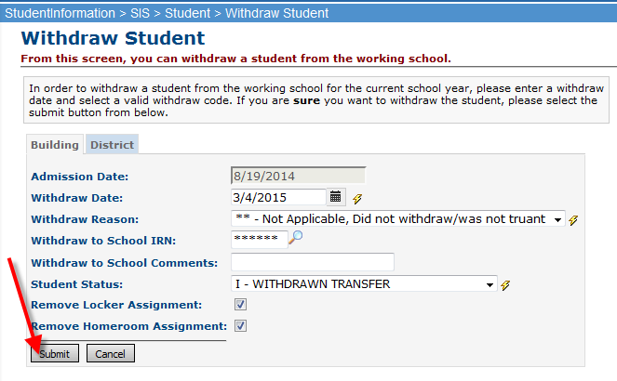
Step 2: Transfer the student using the Transfer Student link on the Student Menu. You will need to select the school year for the student to be available, as well as the District and Building you are sending the student to.
Navigation: StudentInformation > SIS > Student > Student Transfer
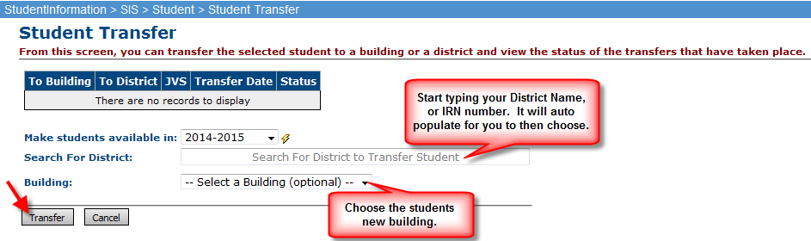

- Once the transfer button is pressed, you will see the transfer pending. The student is now waiting for the receiving building to register.

Step 3: Switch to the new building. Search for Pending Students and click “Detail” next to the student you would like to enroll.
Navigation: StudentInformation > Management > School Administration > Student Transfer > Pending Students
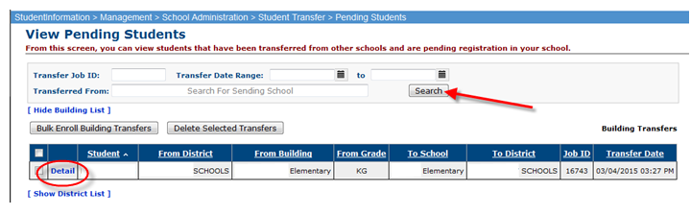
Step 4: Click on the next to the Building you would like to student to be enrolled. You will now be directed to the Registration Wizard to complete the registration to the new school building.
Navigation: StudentInformation > Management > School Administration > Student Transfer > Pending Student Detail
